**Compiler Scanner #2:**

**1-Symbols:**

**1.1-Symbols Regular Expression:**

RE=(+|-|*|/|&&|~|oo|=|.|==|<|>|<=|>=|!=|{|}|(|)|[|]|,|@|;)

**1.2-Symbols NFA:**

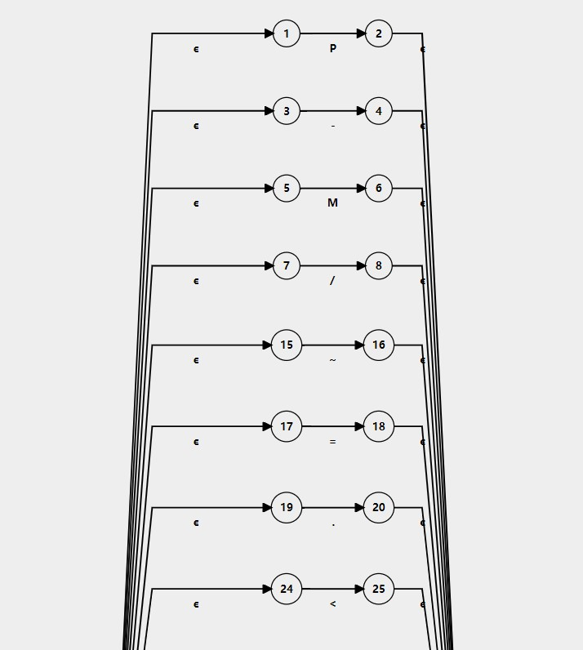

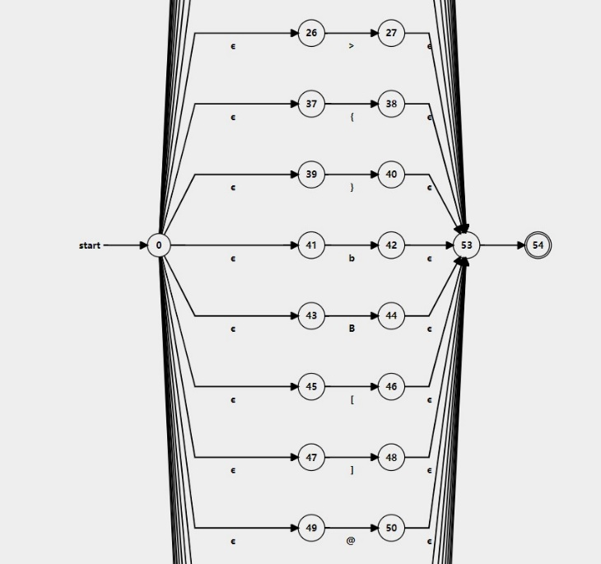

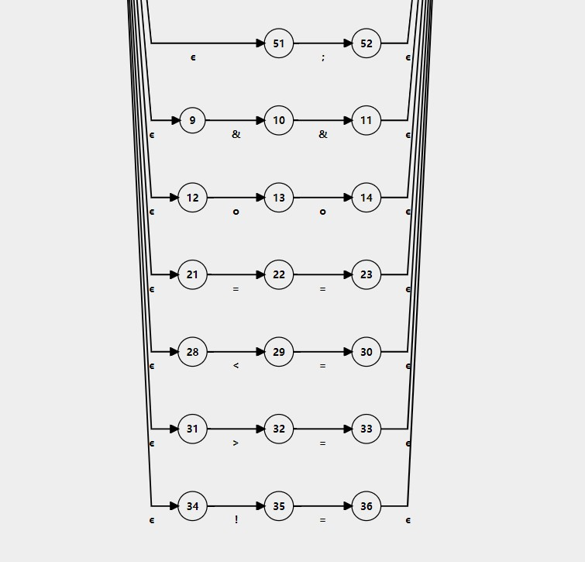

**1.3-Symbols Transition table:**

|  |  |  |  |  |  |  |  |  |  |  |  |  |  |  |  |  |  |  |  |  |  |  |  |
| --- | --- | --- | --- | --- | --- | --- | --- | --- | --- | --- | --- | --- | --- | --- | --- | --- | --- | --- | --- | --- | --- | --- | --- |
| **NFA STATE** | **DFA STATE** | **TYPE** | **!** | **&** | **,** | **-** | **.** | **/** | **)** | **(** | **;** | **<** | **=** | **>** | **@** | **\*** | **+** | **[** | **]** | **o** | **{** | **}** | **~** |
| {0,1,3,5,7,9,12,14,17,19,21,24,26,28,31,34,37,39,41,43,45,47,49,51,53} | A |  | B | C | D | E | F | G | H | I | J | K | L | M | N | O | P | Q | R | S | T | U | V |
| {35} | B |  |  |  |  |  |  |  |  |  |  |  | W |  |  |  |  |  |  |  |  |  |  |
| {10} | C |  |  | X |  |  |  |  |  |  |  |  |  |  |  |  |  |  |  |  |  |  |  |
| {50,55} | D |  |  |  |  |  |  |  |  |  |  |  |  |  |  |  |  |  |  |  |  |  |  |
| {4,55} | E |  |  |  |  |  |  |  |  |  |  |  |  |  |  |  |  |  |  |  |  |  |  |
| {20,55} | F |  |  |  |  |  |  |  |  |  |  |  |  |  |  |  |  |  |  |  |  |  |  |
| {8,55} | G |  |  |  |  |  |  |  |  |  |  |  |  |  |  |  |  |  |  |  |  |  |  |
| {44,55} | H |  |  |  |  |  |  |  |  |  |  |  |  |  |  |  |  |  |  |  |  |  |  |
| {42,55} | I |  |  |  |  |  |  |  |  |  |  |  |  |  |  |  |  |  |  |  |  |  |  |
| {54,55} | J |  |  |  |  |  |  |  |  |  |  |  |  |  |  |  |  |  |  |  |  |  |  |
| {25,29,55} | K |  |  |  |  |  |  |  |  |  |  |  | Y |  |  |  |  |  |  |  |  |  |  |
| {18,22,55} | L |  |  |  |  |  |  |  |  |  |  |  | Z |  |  |  |  |  |  |  |  |  |  |
| {27,32,55} | M |  |  |  |  |  |  |  |  |  |  |  | AA |  |  |  |  |  |  |  |  |  |  |
| {52,55} | N |  |  |  |  |  |  |  |  |  |  |  |  |  |  |  |  |  |  |  |  |  |  |
| {6,55} | O | accept |  |  |  |  |  |  |  |  |  |  |  |  |  |  |  |  |  |  |  |  |  |
| {2,55} | P | accept |  |  |  |  |  |  |  |  |  |  |  |  |  |  |  |  |  |  |  |  |  |
| {46,55} | Q | accept |  |  |  |  |  |  |  |  |  |  |  |  |  |  |  |  |  |  |  |  |  |
| {48,55} | R | accept |  |  |  |  |  |  |  |  |  |  |  |  |  |  |  |  |  |  |  |  |  |
| {15} | S |  |  |  |  |  |  |  |  |  |  |  |  |  |  |  |  |  |  | AB |  |  |  |
| {38,55} | T | accept |  |  |  |  |  |  |  |  |  |  |  |  |  |  |  |  |  |  |  |  |  |
| {40,55} | U | accept |  |  |  |  |  |  |  |  |  |  |  |  |  |  |  |  |  |  |  |  |  |
| {13,55} | V | accept |  |  |  |  |  |  |  |  |  |  |  |  |  |  |  |  |  |  |  |  |  |
| {36,55} | W | accept |  |  |  |  |  |  |  |  |  |  |  |  |  |  |  |  |  |  |  |  |  |
| {11,55} | X | accept |  |  |  |  |  |  |  |  |  |  |  |  |  |  |  |  |  |  |  |  |  |
| {30,55} | Y | accept |  |  |  |  |  |  |  |  |  |  |  |  |  |  |  |  |  |  |  |  |  |
| {23,55} | Z | accept |  |  |  |  |  |  |  |  |  |  |  |  |  |  |  |  |  |  |  |  |  |
| {33,55} | AA | accept |  |  |  |  |  |  |  |  |  |  |  |  |  |  |  |  |  |  |  |  |  |
| {16,55} | AB | accept |  |  |  |  |  |  |  |  |  |  |  |  |  |  |  |  |  |  |  |  |  |

**1.4-Symbols DFA:**

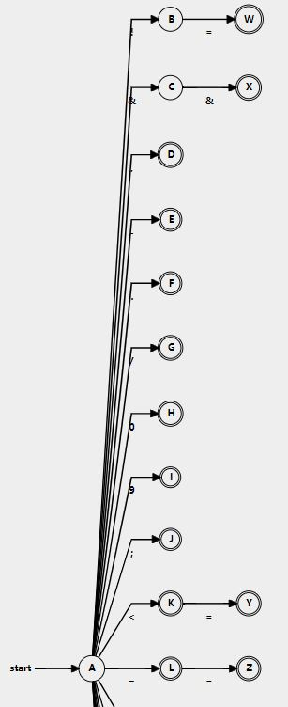

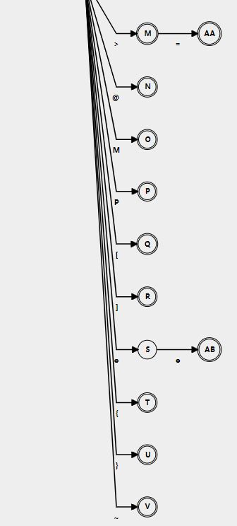

**2-Identifiers:**

**2.1-Identifiers Regular Expression:**

L = ([a-z]|[A-Z]|_)

D=[0-9]

RE=L(L|D)*

**2.2-Identifiers NFA:**

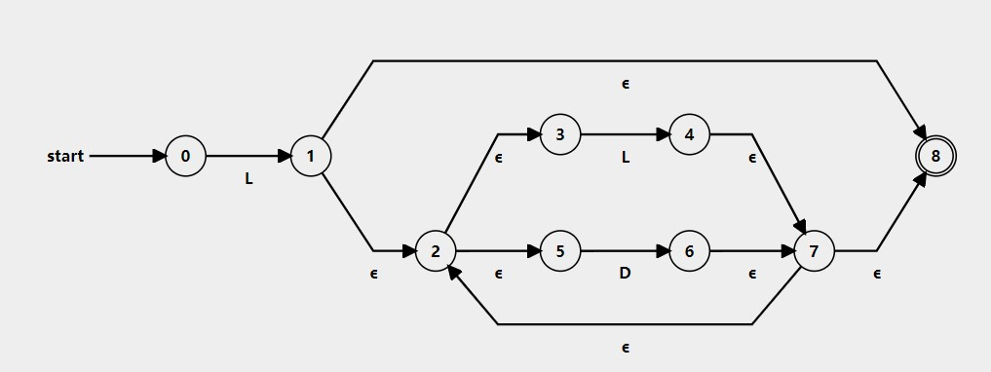

**2.3-Identifiers Transition Table:**

|  |  |  |  |  |
| --- | --- | --- | --- | --- |
| **NFA STATE** | **DFA STATE** | **TYPE** | **D** | **L** |
| {0} | A |  |  | B |
| {1,2,3,5,8} | B | accept | C | D |
| {2,3,5,6,7,8} | C | accept | C | D |
| {2,3,4,5,7,8} | D | accept | C | D |

**2.4-Identifiers DFA:**

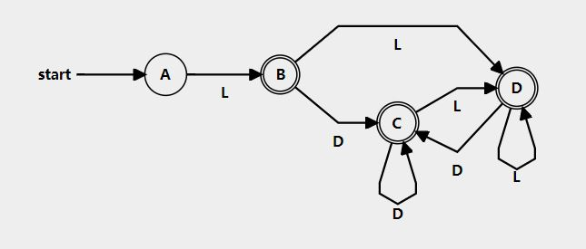

**3-Keywords:**

**3.1-Keywords Regular Expression:**

RE=(Divisio|InferedFrom|WhetherDo|Else|Ire|Sire|Clo|SetOfClo|FBU|SFBU|NoneValue|TerminateThisNow|RingWhen|BackedValue|STT|Check|CaseOf|Beginning|End|Using)

**3.2-Keywords NFA:**

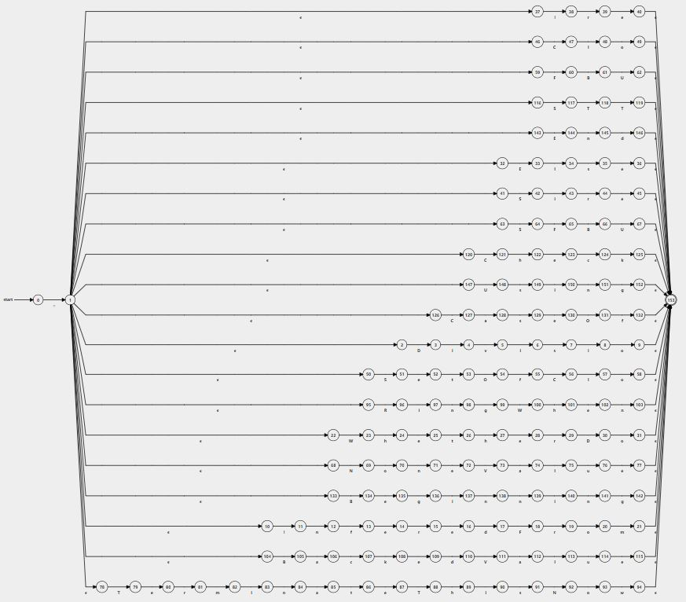

**3.3-Keywords Transition Table:**

|  |  |  |  |  |  |  |  |  |  |  |  |  |  |  |  |  |  |  |  |  |  |  |  |  |  |  |  |  |  |  |  |  |  |  |  |  |
| --- | --- | --- | --- | --- | --- | --- | --- | --- | --- | --- | --- | --- | --- | --- | --- | --- | --- | --- | --- | --- | --- | --- | --- | --- | --- | --- | --- | --- | --- | --- | --- | --- | --- | --- | --- | --- |
| NFA STATE | DFA STATE | TYPE | = | B | C | D | E | F | I | N | O | R | S | T | U | V | W | a | c | d | e | f | g | h | i | k | l | m | n | o | r | s | t | u | v | w |
| {0} | A |  | B |  |  |  |  |  |  |  |  |  |  |  |  |  |  |  |  |  |  |  |  |  |  |  |  |  |  |  |  |  |  |  |  |  |
| {1,2,10,22,32,37,41,46,50,59,63,68,78,95,104,116,120,126,133,143,147} | B |  |  | C | D | E | F | G | H | I |  | J | K | L | M |  | N |  |  |  |  |  |  |  |  |  |  |  |  |  |  |  |  |  |  |  |
| {105,134} | C |  |  |  |  |  |  |  |  |  |  |  |  |  |  |  |  | O |  |  | P |  |  |  |  |  |  |  |  |  |  |  |  |  |  |  |
| {47,121,127} | D |  |  |  |  |  |  |  |  |  |  |  |  |  |  |  |  | Q |  |  |  |  |  | R |  |  | S |  |  |  |  |  |  |  |  |  |
| {3} | E |  |  |  |  |  |  |  |  |  |  |  |  |  |  |  |  |  |  |  |  |  |  |  | T |  |  |  |  |  |  |  |  |  |  |  |
| {33,144} | F |  |  |  |  |  |  |  |  |  |  |  |  |  |  |  |  |  |  |  |  |  |  |  |  |  | U |  | V |  |  |  |  |  |  |  |
| {60} | G |  |  | W |  |  |  |  |  |  |  |  |  |  |  |  |  |  |  |  |  |  |  |  |  |  |  |  |  |  |  |  |  |  |  |  |
| {11,38} | H |  |  |  |  |  |  |  |  |  |  |  |  |  |  |  |  |  |  |  |  |  |  |  |  |  |  |  | X |  | Y |  |  |  |  |  |
| {69} | I |  |  |  |  |  |  |  |  |  |  |  |  |  |  |  |  |  |  |  |  |  |  |  |  |  |  |  |  | Z |  |  |  |  |  |  |
| {96} | J |  |  |  |  |  |  |  |  |  |  |  |  |  |  |  |  |  |  |  |  |  |  |  | AA |  |  |  |  |  |  |  |  |  |  |  |
| {42,51,64,117} | K |  |  |  |  |  |  | AB |  |  |  |  |  | AC |  |  |  |  |  |  | AD |  |  |  | AE |  |  |  |  |  |  |  |  |  |  |  |
| {79} | L |  |  |  |  |  |  |  |  |  |  |  |  |  |  |  |  |  |  |  | AF |  |  |  |  |  |  |  |  |  |  |  |  |  |  |  |
| {148} | M |  |  |  |  |  |  |  |  |  |  |  |  |  |  |  |  |  |  |  |  |  |  |  |  |  |  |  |  |  |  | AG |  |  |  |  |
| {23} | N |  |  |  |  |  |  |  |  |  |  |  |  |  |  |  |  |  |  |  |  |  |  | AH |  |  |  |  |  |  |  |  |  |  |  |  |
| {106} | O |  |  |  |  |  |  |  |  |  |  |  |  |  |  |  |  |  | AI |  |  |  |  |  |  |  |  |  |  |  |  |  |  |  |  |  |
| {135} | P |  |  |  |  |  |  |  |  |  |  |  |  |  |  |  |  |  |  |  |  |  | AJ |  |  |  |  |  |  |  |  |  |  |  |  |  |
| {128} | Q |  |  |  |  |  |  |  |  |  |  |  |  |  |  |  |  |  |  |  |  |  |  |  |  |  |  |  |  |  |  | AK |  |  |  |  |
| {122} | R |  |  |  |  |  |  |  |  |  |  |  |  |  |  |  |  |  |  |  | AL |  |  |  |  |  |  |  |  |  |  |  |  |  |  |  |
| {48} | S |  |  |  |  |  |  |  |  |  |  |  |  |  |  |  |  |  |  |  |  |  |  |  |  |  |  |  |  | AM |  |  |  |  |  |  |
| {4} | T |  |  |  |  |  |  |  |  |  |  |  |  |  |  |  |  |  |  |  |  |  |  |  |  |  |  |  |  |  |  |  |  |  | AN |  |
| {34} | U |  |  |  |  |  |  |  |  |  |  |  |  |  |  |  |  |  |  |  |  |  |  |  |  |  |  |  |  |  |  | AO |  |  |  |  |
| {145} | V |  |  |  |  |  |  |  |  |  |  |  |  |  |  |  |  |  |  | AP |  |  |  |  |  |  |  |  |  |  |  |  |  |  |  |  |
| {61} | W |  |  |  |  |  |  |  |  |  |  |  |  |  | AQ |  |  |  |  |  |  |  |  |  |  |  |  |  |  |  |  |  |  |  |  |  |
| {12} | X |  |  |  |  |  |  |  |  |  |  |  |  |  |  |  |  |  |  |  |  | AR |  |  |  |  |  |  |  |  |  |  |  |  |  |  |
| {39} | Y |  |  |  |  |  |  |  |  |  |  |  |  |  |  |  |  |  |  |  | AS |  |  |  |  |  |  |  |  |  |  |  |  |  |  |  |
| {70} | Z |  |  |  |  |  |  |  |  |  |  |  |  |  |  |  |  |  |  |  |  |  |  |  |  |  |  |  | AT |  |  |  |  |  |  |  |
| {97} | AA |  |  |  |  |  |  |  |  |  |  |  |  |  |  |  |  |  |  |  |  |  |  |  |  |  |  |  | AU |  |  |  |  |  |  |  |
| {65} | AB |  |  | AV |  |  |  |  |  |  |  |  |  |  |  |  |  |  |  |  |  |  |  |  |  |  |  |  |  |  |  |  |  |  |  |  |
| {118} | AC |  |  |  |  |  |  |  |  |  |  |  |  | AW |  |  |  |  |  |  |  |  |  |  |  |  |  |  |  |  |  |  |  |  |  |  |
| {52} | AD |  |  |  |  |  |  |  |  |  |  |  |  |  |  |  |  |  |  |  |  |  |  |  |  |  |  |  |  |  |  |  | AX |  |  |  |
| {43} | AE |  |  |  |  |  |  |  |  |  |  |  |  |  |  |  |  |  |  |  |  |  |  |  |  |  |  |  |  |  | AY |  |  |  |  |  |
| {80} | AF |  |  |  |  |  |  |  |  |  |  |  |  |  |  |  |  |  |  |  |  |  |  |  |  |  |  |  |  |  | AZ |  |  |  |  |  |
| {149} | AG |  |  |  |  |  |  |  |  |  |  |  |  |  |  |  |  |  |  |  |  |  |  |  | BA |  |  |  |  |  |  |  |  |  |  |  |
| {24} | AH |  |  |  |  |  |  |  |  |  |  |  |  |  |  |  |  |  |  |  | BB |  |  |  |  |  |  |  |  |  |  |  |  |  |  |  |
| {107} | AI |  |  |  |  |  |  |  |  |  |  |  |  |  |  |  |  |  |  |  |  |  |  |  |  | BC |  |  |  |  |  |  |  |  |  |  |
| {136} | AJ |  |  |  |  |  |  |  |  |  |  |  |  |  |  |  |  |  |  |  |  |  |  |  | BD |  |  |  |  |  |  |  |  |  |  |  |
| {129} | AK |  |  |  |  |  |  |  |  |  |  |  |  |  |  |  |  |  |  |  | BE |  |  |  |  |  |  |  |  |  |  |  |  |  |  |  |
| {123} | AL |  |  |  |  |  |  |  |  |  |  |  |  |  |  |  |  |  | BF |  |  |  |  |  |  |  |  |  |  |  |  |  |  |  |  |  |
| {49,153} | AM | accept |  |  |  |  |  |  |  |  |  |  |  |  |  |  |  |  |  |  |  |  |  |  |  |  |  |  |  |  |  |  |  |  |  |  |
| {5} | AN |  |  |  |  |  |  |  |  |  |  |  |  |  |  |  |  |  |  |  |  |  |  |  | BG |  |  |  |  |  |  |  |  |  |  |  |
| {35} | AO |  |  |  |  |  |  |  |  |  |  |  |  |  |  |  |  |  |  |  | BH |  |  |  |  |  |  |  |  |  |  |  |  |  |  |  |
| {146,153} | AP | accept |  |  |  |  |  |  |  |  |  |  |  |  |  |  |  |  |  |  |  |  |  |  |  |  |  |  |  |  |  |  |  |  |  |  |
| {62,153} | AQ | accept |  |  |  |  |  |  |  |  |  |  |  |  |  |  |  |  |  |  |  |  |  |  |  |  |  |  |  |  |  |  |  |  |  |  |
| {13} | AR |  |  |  |  |  |  |  |  |  |  |  |  |  |  |  |  |  |  |  | BI |  |  |  |  |  |  |  |  |  |  |  |  |  |  |  |
| {40,153} | AS | accept |  |  |  |  |  |  |  |  |  |  |  |  |  |  |  |  |  |  |  |  |  |  |  |  |  |  |  |  |  |  |  |  |  |  |
| {71} | AT |  |  |  |  |  |  |  |  |  |  |  |  |  |  |  |  |  |  |  | BJ |  |  |  |  |  |  |  |  |  |  |  |  |  |  |  |
| {98} | AU |  |  |  |  |  |  |  |  |  |  |  |  |  |  |  |  |  |  |  |  |  | BK |  |  |  |  |  |  |  |  |  |  |  |  |  |
| {66} | AV |  |  |  |  |  |  |  |  |  |  |  |  |  | BL |  |  |  |  |  |  |  |  |  |  |  |  |  |  |  |  |  |  |  |  |  |
| {119,153} | AW | accept |  |  |  |  |  |  |  |  |  |  |  |  |  |  |  |  |  |  |  |  |  |  |  |  |  |  |  |  |  |  |  |  |  |  |
| {53} | AX |  |  |  |  |  |  |  |  |  | BM |  |  |  |  |  |  |  |  |  |  |  |  |  |  |  |  |  |  |  |  |  |  |  |  |  |
| {44} | AY |  |  |  |  |  |  |  |  |  |  |  |  |  |  |  |  |  |  |  | BN |  |  |  |  |  |  |  |  |  |  |  |  |  |  |  |
| {81} | AZ |  |  |  |  |  |  |  |  |  |  |  |  |  |  |  |  |  |  |  |  |  |  |  |  |  |  | BO |  |  |  |  |  |  |  |  |
| {150} | BA |  |  |  |  |  |  |  |  |  |  |  |  |  |  |  |  |  |  |  |  |  |  |  |  |  |  |  | BP |  |  |  |  |  |  |  |
| {25} | BB |  |  |  |  |  |  |  |  |  |  |  |  |  |  |  |  |  |  |  |  |  |  |  |  |  |  |  |  |  |  |  | BQ |  |  |  |
| {108} | BC |  |  |  |  |  |  |  |  |  |  |  |  |  |  |  |  |  |  |  | BR |  |  |  |  |  |  |  |  |  |  |  |  |  |  |  |
| {137} | BD |  |  |  |  |  |  |  |  |  |  |  |  |  |  |  |  |  |  |  |  |  |  |  |  |  |  |  | BS |  |  |  |  |  |  |  |
| {130} | BE |  |  |  |  |  |  |  |  |  | BT |  |  |  |  |  |  |  |  |  |  |  |  |  |  |  |  |  |  |  |  |  |  |  |  |  |
| {124} | BF |  |  |  |  |  |  |  |  |  |  |  |  |  |  |  |  |  |  |  |  |  |  |  |  | BU |  |  |  |  |  |  |  |  |  |  |
| {6} | BG |  |  |  |  |  |  |  |  |  |  |  |  |  |  |  |  |  |  |  |  |  |  |  |  |  |  |  |  |  |  | BV |  |  |  |  |
| {36,153} | BH | accept |  |  |  |  |  |  |  |  |  |  |  |  |  |  |  |  |  |  |  |  |  |  |  |  |  |  |  |  |  |  |  |  |  |  |
| {14} | BI |  |  |  |  |  |  |  |  |  |  |  |  |  |  |  |  |  |  |  |  |  |  |  |  |  |  |  |  |  | BW |  |  |  |  |  |
| {72} | BJ |  |  |  |  |  |  |  |  |  |  |  |  |  |  | BX |  |  |  |  |  |  |  |  |  |  |  |  |  |  |  |  |  |  |  |  |
| {99} | BK |  |  |  |  |  |  |  |  |  |  |  |  |  |  |  | BY |  |  |  |  |  |  |  |  |  |  |  |  |  |  |  |  |  |  |  |
| {67,153} | BL | accept |  |  |  |  |  |  |  |  |  |  |  |  |  |  |  |  |  |  |  |  |  |  |  |  |  |  |  |  |  |  |  |  |  |  |
| {54} | BM |  |  |  |  |  |  |  |  |  |  |  |  |  |  |  |  |  |  |  |  | BZ |  |  |  |  |  |  |  |  |  |  |  |  |  |  |
| {45,153} | BN | accept |  |  |  |  |  |  |  |  |  |  |  |  |  |  |  |  |  |  |  |  |  |  |  |  |  |  |  |  |  |  |  |  |  |  |
| {82} | BO |  |  |  |  |  |  |  |  |  |  |  |  |  |  |  |  |  |  |  |  |  |  |  | CA |  |  |  |  |  |  |  |  |  |  |  |
| {151} | BP |  |  |  |  |  |  |  |  |  |  |  |  |  |  |  |  |  |  |  |  |  | CB |  |  |  |  |  |  |  |  |  |  |  |  |  |
| {26} | BQ |  |  |  |  |  |  |  |  |  |  |  |  |  |  |  |  |  |  |  |  |  |  | CC |  |  |  |  |  |  |  |  |  |  |  |  |
| {109} | BR |  |  |  |  |  |  |  |  |  |  |  |  |  |  |  |  |  |  | CD |  |  |  |  |  |  |  |  |  |  |  |  |  |  |  |  |
| {138} | BS |  |  |  |  |  |  |  |  |  |  |  |  |  |  |  |  |  |  |  |  |  |  |  |  |  |  |  | CE |  |  |  |  |  |  |  |
| {131} | BT |  |  |  |  |  |  |  |  |  |  |  |  |  |  |  |  |  |  |  |  | CF |  |  |  |  |  |  |  |  |  |  |  |  |  |  |
| {125,153} | BU | accept |  |  |  |  |  |  |  |  |  |  |  |  |  |  |  |  |  |  |  |  |  |  |  |  |  |  |  |  |  |  |  |  |  |  |
| {7} | BV |  |  |  |  |  |  |  |  |  |  |  |  |  |  |  |  |  |  |  |  |  |  |  | CG |  |  |  |  |  |  |  |  |  |  |  |
| {15} | BW |  |  |  |  |  |  |  |  |  |  |  |  |  |  |  |  |  |  |  | CH |  |  |  |  |  |  |  |  |  |  |  |  |  |  |  |
| {73} | BX |  |  |  |  |  |  |  |  |  |  |  |  |  |  |  |  | CI |  |  |  |  |  |  |  |  |  |  |  |  |  |  |  |  |  |  |
| {100} | BY |  |  |  |  |  |  |  |  |  |  |  |  |  |  |  |  |  |  |  |  |  |  | CJ |  |  |  |  |  |  |  |  |  |  |  |  |
| {55} | BZ |  |  |  | CK |  |  |  |  |  |  |  |  |  |  |  |  |  |  |  |  |  |  |  |  |  |  |  |  |  |  |  |  |  |  |  |
| {83} | CA |  |  |  |  |  |  |  |  |  |  |  |  |  |  |  |  |  |  |  |  |  |  |  |  |  |  |  | CL |  |  |  |  |  |  |  |
| {152,153} | CB | accept |  |  |  |  |  |  |  |  |  |  |  |  |  |  |  |  |  |  |  |  |  |  |  |  |  |  |  |  |  |  |  |  |  |  |
| {27} | CC |  |  |  |  |  |  |  |  |  |  |  |  |  |  |  |  |  |  |  | CM |  |  |  |  |  |  |  |  |  |  |  |  |  |  |  |
| {110} | CD |  |  |  |  |  |  |  |  |  |  |  |  |  |  | CN |  |  |  |  |  |  |  |  |  |  |  |  |  |  |  |  |  |  |  |  |
| {139} | CE |  |  |  |  |  |  |  |  |  |  |  |  |  |  |  |  |  |  |  |  |  |  |  | CO |  |  |  |  |  |  |  |  |  |  |  |
| {132,153} | CF | accept |  |  |  |  |  |  |  |  |  |  |  |  |  |  |  |  |  |  |  |  |  |  |  |  |  |  |  |  |  |  |  |  |  |  |
| {8} | CG |  |  |  |  |  |  |  |  |  |  |  |  |  |  |  |  |  |  |  |  |  |  |  |  |  |  |  |  | CP |  |  |  |  |  |  |
| {16} | CH |  |  |  |  |  |  |  |  |  |  |  |  |  |  |  |  |  |  | CQ |  |  |  |  |  |  |  |  |  |  |  |  |  |  |  |  |
| {74} | CI |  |  |  |  |  |  |  |  |  |  |  |  |  |  |  |  |  |  |  |  |  |  |  |  |  | CR |  |  |  |  |  |  |  |  |  |
| {101} | CJ |  |  |  |  |  |  |  |  |  |  |  |  |  |  |  |  |  |  |  | CS |  |  |  |  |  |  |  |  |  |  |  |  |  |  |  |
| {56} | CK |  |  |  |  |  |  |  |  |  |  |  |  |  |  |  |  |  |  |  |  |  |  |  |  |  | CT |  |  |  |  |  |  |  |  |  |
| {84} | CL |  |  |  |  |  |  |  |  |  |  |  |  |  |  |  |  | CU |  |  |  |  |  |  |  |  |  |  |  |  |  |  |  |  |  |  |
| {28} | CM |  |  |  |  |  |  |  |  |  |  |  |  |  |  |  |  |  |  |  |  |  |  |  |  |  |  |  |  |  | CV |  |  |  |  |  |
| {111} | CN |  |  |  |  |  |  |  |  |  |  |  |  |  |  |  |  | CW |  |  |  |  |  |  |  |  |  |  |  |  |  |  |  |  |  |  |
| {140} | CO |  |  |  |  |  |  |  |  |  |  |  |  |  |  |  |  |  |  |  |  |  |  |  |  |  |  |  | CX |  |  |  |  |  |  |  |
| {9,153} | CP | accept |  |  |  |  |  |  |  |  |  |  |  |  |  |  |  |  |  |  |  |  |  |  |  |  |  |  |  |  |  |  |  |  |  |  |
| {17} | CQ |  |  |  |  |  |  | CY |  |  |  |  |  |  |  |  |  |  |  |  |  |  |  |  |  |  |  |  |  |  |  |  |  |  |  |  |
| {75} | CR |  |  |  |  |  |  |  |  |  |  |  |  |  |  |  |  |  |  |  |  |  |  |  |  |  |  |  |  |  |  |  |  | CZ |  |  |
| {102} | CS |  |  |  |  |  |  |  |  |  |  |  |  |  |  |  |  |  |  |  |  |  |  |  |  |  |  |  | DA |  |  |  |  |  |  |  |
| {57} | CT |  |  |  |  |  |  |  |  |  |  |  |  |  |  |  |  |  |  |  |  |  |  |  |  |  |  |  |  | DB |  |  |  |  |  |  |
| {85} | CU |  |  |  |  |  |  |  |  |  |  |  |  |  |  |  |  |  |  |  |  |  |  |  |  |  |  |  |  |  |  |  | DC |  |  |  |
| {29} | CV |  |  |  |  | DD |  |  |  |  |  |  |  |  |  |  |  |  |  |  |  |  |  |  |  |  |  |  |  |  |  |  |  |  |  |  |
| {112} | CW |  |  |  |  |  |  |  |  |  |  |  |  |  |  |  |  |  |  |  |  |  |  |  |  |  | DE |  |  |  |  |  |  |  |  |  |
| {141} | CX |  |  |  |  |  |  |  |  |  |  |  |  |  |  |  |  |  |  |  |  |  | DF |  |  |  |  |  |  |  |  |  |  |  |  |  |
| {18} | CY |  |  |  |  |  |  |  |  |  |  |  |  |  |  |  |  |  |  |  |  |  |  |  |  |  |  |  |  |  | DG |  |  |  |  |  |
| {76} | CZ |  |  |  |  |  |  |  |  |  |  |  |  |  |  |  |  |  |  |  | DH |  |  |  |  |  |  |  |  |  |  |  |  |  |  |  |
| {103,153} | DA | accept |  |  |  |  |  |  |  |  |  |  |  |  |  |  |  |  |  |  |  |  |  |  |  |  |  |  |  |  |  |  |  |  |  |  |
| {58,153} | DB | accept |  |  |  |  |  |  |  |  |  |  |  |  |  |  |  |  |  |  |  |  |  |  |  |  |  |  |  |  |  |  |  |  |  |  |
| {86} | DC |  |  |  |  |  |  |  |  |  |  |  |  |  |  |  |  |  |  |  | DI |  |  |  |  |  |  |  |  |  |  |  |  |  |  |  |
| {30} | DD |  |  |  |  |  |  |  |  |  |  |  |  |  |  |  |  |  |  |  |  |  |  |  |  |  |  |  |  | DJ |  |  |  |  |  |  |
| {113} | DE |  |  |  |  |  |  |  |  |  |  |  |  |  |  |  |  |  |  |  |  |  |  |  |  |  |  |  |  |  |  |  |  | DK |  |  |
| {142,153} | DF | accept |  |  |  |  |  |  |  |  |  |  |  |  |  |  |  |  |  |  |  |  |  |  |  |  |  |  |  |  |  |  |  |  |  |  |
| {19} | DG |  |  |  |  |  |  |  |  |  |  |  |  |  |  |  |  |  |  |  |  |  |  |  |  |  |  |  |  | DL |  |  |  |  |  |  |
| {77,153} | DH | accept |  |  |  |  |  |  |  |  |  |  |  |  |  |  |  |  |  |  |  |  |  |  |  |  |  |  |  |  |  |  |  |  |  |  |
| {87} | DI |  |  |  |  |  |  |  |  |  |  |  |  | DM |  |  |  |  |  |  |  |  |  |  |  |  |  |  |  |  |  |  |  |  |  |  |
| {31,153} | DJ | accept |  |  |  |  |  |  |  |  |  |  |  |  |  |  |  |  |  |  |  |  |  |  |  |  |  |  |  |  |  |  |  |  |  |  |
| {114} | DK |  |  |  |  |  |  |  |  |  |  |  |  |  |  |  |  |  |  |  | DN |  |  |  |  |  |  |  |  |  |  |  |  |  |  |  |
| {20} | DL |  |  |  |  |  |  |  |  |  |  |  |  |  |  |  |  |  |  |  |  |  |  |  |  |  |  | DO |  |  |  |  |  |  |  |  |
| {88} | DM |  |  |  |  |  |  |  |  |  |  |  |  |  |  |  |  |  |  |  |  |  |  | DP |  |  |  |  |  |  |  |  |  |  |  |  |
| {115,153} | DN | accept |  |  |  |  |  |  |  |  |  |  |  |  |  |  |  |  |  |  |  |  |  |  |  |  |  |  |  |  |  |  |  |  |  |  |
| {21,153} | DO | accept |  |  |  |  |  |  |  |  |  |  |  |  |  |  |  |  |  |  |  |  |  |  |  |  |  |  |  |  |  |  |  |  |  |  |
| {89} | DP |  |  |  |  |  |  |  |  |  |  |  |  |  |  |  |  |  |  |  |  |  |  |  | DQ |  |  |  |  |  |  |  |  |  |  |  |
| {90} | DQ |  |  |  |  |  |  |  |  |  |  |  |  |  |  |  |  |  |  |  |  |  |  |  |  |  |  |  |  |  |  | DR |  |  |  |  |
| {91} | DR |  |  |  |  |  |  |  |  | DS |  |  |  |  |  |  |  |  |  |  |  |  |  |  |  |  |  |  |  |  |  |  |  |  |  |  |
| {92} | DS |  |  |  |  |  |  |  |  |  |  |  |  |  |  |  |  |  |  |  |  |  |  |  |  |  |  |  |  | DT |  |  |  |  |  |  |
| {93} | DT |  |  |  |  |  |  |  |  |  |  |  |  |  |  |  |  |  |  |  |  |  |  |  |  |  |  |  |  |  |  |  |  |  |  | DU |
| {94,153} | DU | accept |  |  |  |  |  |  |  |  |  |  |  |  |  |  |  |  |  |  |  |  |  |  |  |  |  |  |  |  |  |  |  |  |  |  |

**3.4-Keywords DFA:**

